**WEB TECHNOLOGY**

Name: **NEERAJ SHARMA**

Roll No. : 01014807216

Semester: 6th

Group: C-12



Maharaja Agrasen Institute Of Technology, PSP Area,

Sector-22, Rohini, New Delhi-110086

**WEB TECHNOLOGY**

**PAPER CODE** : **ETCS-308**

NAME OF THE STUDENT : NEERAJ SHARMA

UNIVERSITY ROLL NO : 01014807216

BRANCH : CSE

SECTION/GROUP : C-12

PRACTICAL DETAILS

|  |  |  |  |  |  |
| --- | --- | --- | --- | --- | --- |
| S.NO | EXPERIMENT NAME | DATE OF PERFORMANCE | DATE OF CHECKING | REMARKS | MARKS |
|  |  |  |  |  |  |
|  |  |  |  |  |  |
|  |  |  |  |  |  |
|  |  |  |  |  |  |
|  |  |  |  |  |  |
|  |  |  |  |  |  |
|  |  |  |  |  |  |

**WEEK -1**

Aim: Static web page in html

<!DOCTYPE html>

<html>

<head>

<meta http-equiv="content-type" content="text/html; charset=windows-1252">

<title>neeraj

</title>

</head>

<body background="https://thumbs.dreamstime.com/z/vintage-grunge-old-paper-texture-as-background-space-text-image-36833737.jpg">

<font color="#670505" face="comic sans" size="72">

<h1 align="center">

ART PAGE

</h1>

</font>

<font color="#473b29" face="comfortaa" size="50">

<p align="center">

"My first sketch"

</p>

</font>

<div>

<b>

<font style="color: black;size: 72pt;"></font>

</b>

</div>

<footer style="position: absolute; bottom: 10px; width: 99%">

<div align="center">

<font style="color: black;">

created by neeraj sharma

</font>

</div>

</footer>

</body>

</html>

Aim: Installing Xampp on Computer

Xampp for windows 7 version provides an easy to install apache-mysql-php-perl-pear framework. Xampp saves time and effort and provides the software support for web frameworks like drupal, joomla, moodle, or wikimedia on any windows pc.

Steps:

1. Download the installer file for the latest version of XAMPP, and save the file to your computer

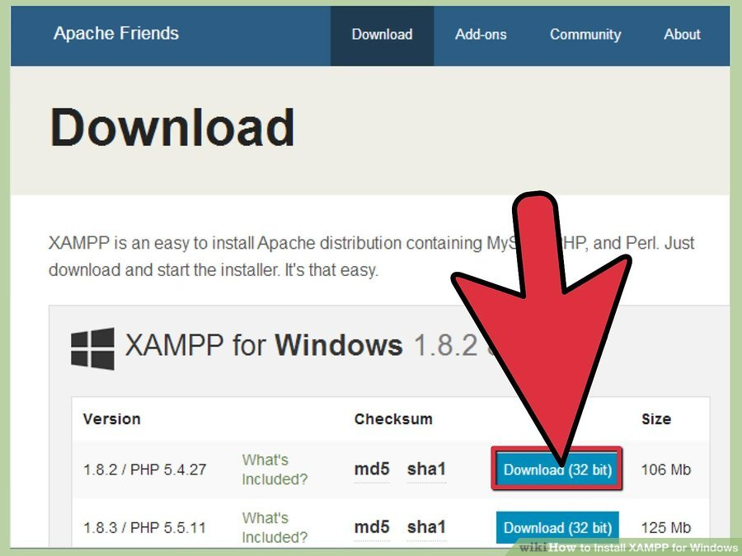

1. Open CD or DVD drive from My Computer. Install the program, and click on "Run
2. Accept the default settings. A command will open and offer an initial installation prompt. Just hit the Enter key, and accept the default settings. You can always change settings, by editing the configuration files later."
3. When your installation is complete, exit the command window by typing x on the command line
4. Start the XAMPP Control Panel

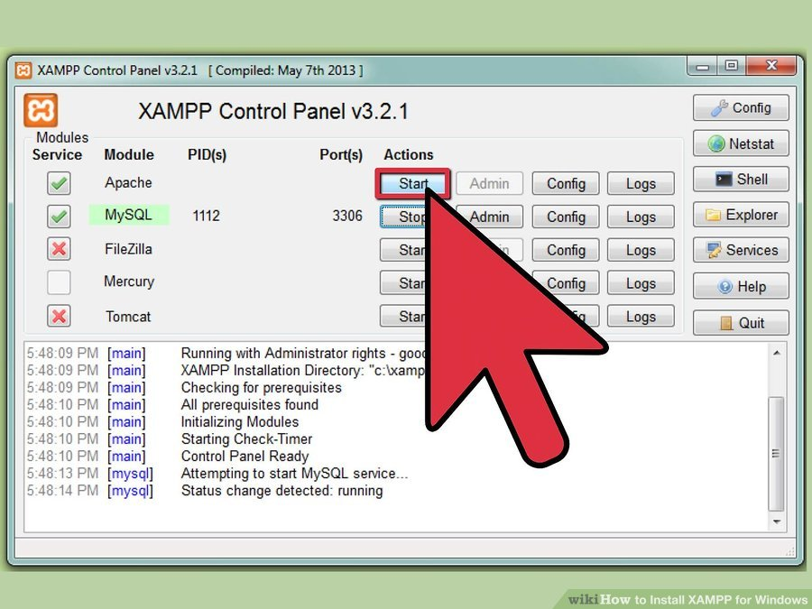

1. Start the Apache and mysql components. You can also start the other components, if you plan to use them
2. Verify the mysql installation, by clicking on the mysql administrative link in the XAMPP Control Panel.
3. If the verification steps are successful, XAMPP should be successfully installed on your PC. Open a browser and enter "localhost" on your address bar. You will be redirected to a page telling you that you've successfully installed xampp on your system

Aim: Creating a simple Form in Css and Html

Program:

<%@page contentType="text/html" pageEncoding="UTF-8"%>

<!DOCTYPE html>

<html>

<head>

<body background="https://thumbs.dreamstime.com/z/vintage-grunge-old-paper-texture-as-background-space-text-image-36833737.jpg">

<meta http-equiv="Content-Type" content="text/html; charset=UTF-8">

<title>upload</title>

<link rel="stylesheet" href="css/deliverycss.css">

</head>

<body>

<div id="menu">

<div id="leftmenu">

<ul>

<li><a href="">Home</a></li>

<li><a href="news.asp">Menu</a></li>

<li><a href="contact.asp">Contact</a></li>

<li><a href="about.asp">About</a></li>

</ul>

</div>

<div id="rightmenu">

<a href="">Admin</a>

<a href="">Cart</a>

</div>

</div>

<div id="quote">

Let us know about you :)

</div>

<div id="container">

<table>

<form action="action_page.php">

<tr>

<td><label for="fname">First Name</label></td>

<td><input type="text" id="fname" name="firstname" placeholder="Your name.."></td>

</tr>

<tr>

<td><label for="about">About</label></td>

<td><input type="text" id="about" name="about" placeholder="about sketch.." style="height:30px"></td>

</tr>

<tr>

<td><label for="country">Country</label></td>

<td>

<select id="country" name="country">

<option value="australia">Australia</option>

<option value="canada">Canada</option>

<option value="usa">USA</option>

<option value="INDIA">INDIA</option>

</select></td>

</tr>

<tr>

<td>

<label for="Email">Email</label>

</td>

<td>

<input type="email" id="email" name="email" placeholder="Mail you @..">

</td></tr>

<tr><td>

<label for="Mobile">Mobile</label>

</td>

<td>

<input type="" id="number" name="number" placeholder="9863..">

</td></tr>

<tr><td colspan="2" align="center"><input type="submit" value="post" ></tr></form></table>

</div><body>

</html>